- marks table with colums
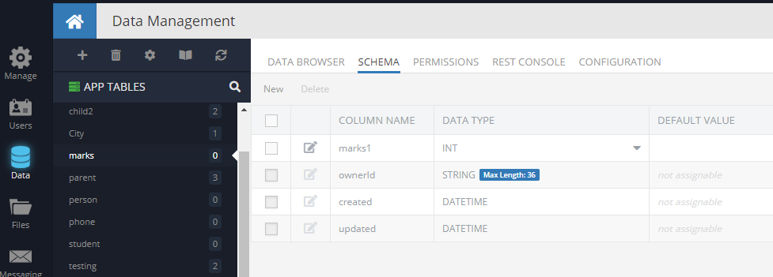
- student table with marks column which has the Data Object relation
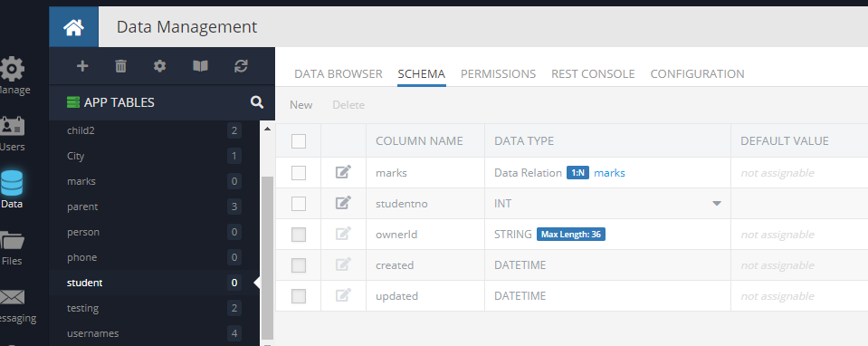
- Request Body
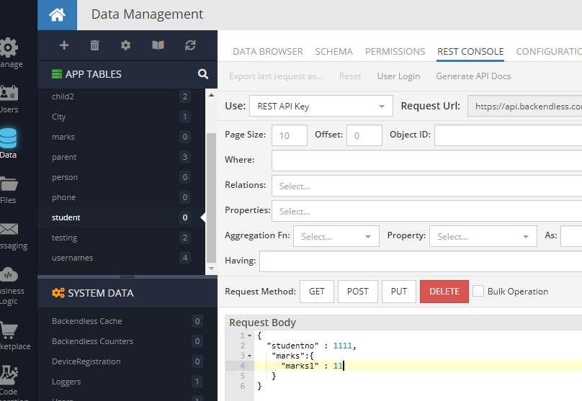
When we click POST the data should go to both the tables i.e student and marks, but it is not happening.

